**Description for my page** (Amal Alwahni U19105519)

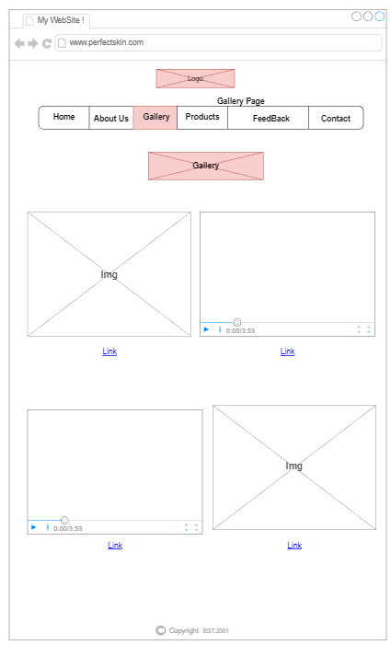

For the Gallery page. I decided to add the logo in the center to make it eye-catching to the visitor. Under it is the button box for other pages. And then the title of the page "Gallery".

On this page, I focused on adding images and videos since it's a gallery page, so I added 2 images and 2 videos, and under each video are links to YouTube. The main purpose of this page is to give the visitor an idea of how the product looks like and how other influencers use and rate them.

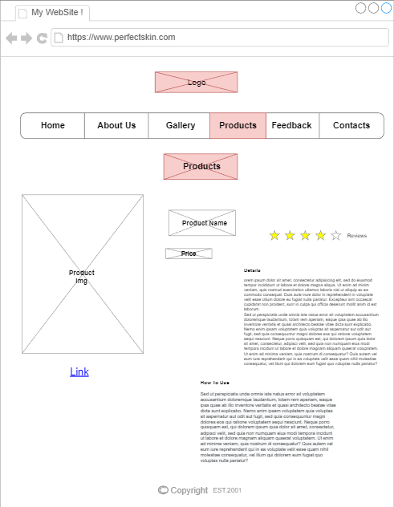

For the Product page. My teammates and I decided to stick to one design for the page for it to look neat and good to the eye when the visitor visits the website.

On the product page, we added the logo in the top center to make it more visible and logical. Under the logo are the buttons for other pages. And then we added an image on the left side of the page. This will display the product's image so the visitor can see what products they are looking at. Next to it is the product name and price. Later comes the rating stars where you can rate the product yourself. On the right side comes the detail paragraph box where we will be adding every important detail about the product. Later down comes the way to use the product. In this paragraph, we will list the ways of using the product the right way. And under the image comes a link that takes you to the product's actual website so you can easily purchase the product if you wish to! At the end of the page, we decided to add the copyright and estimated year of the website.